**Guideline of Apex interface (Trader)**

1. Trader can access the oracle by login with valid username and password.

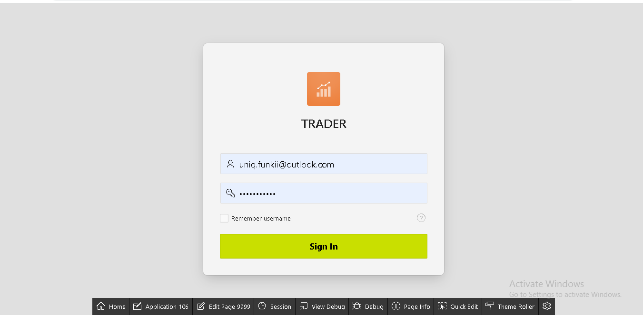

1. Clicking on ‘Shop detail’ gives the clear view about the trader and the shop related to the trader

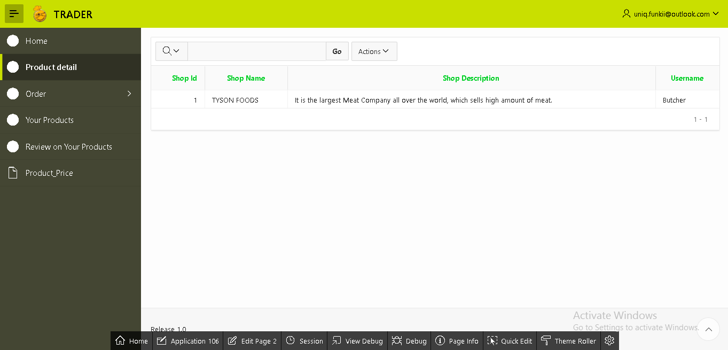

1. Similarly, clicking on Order generates the drop down options for weekly and monthly report of orders by the customer.

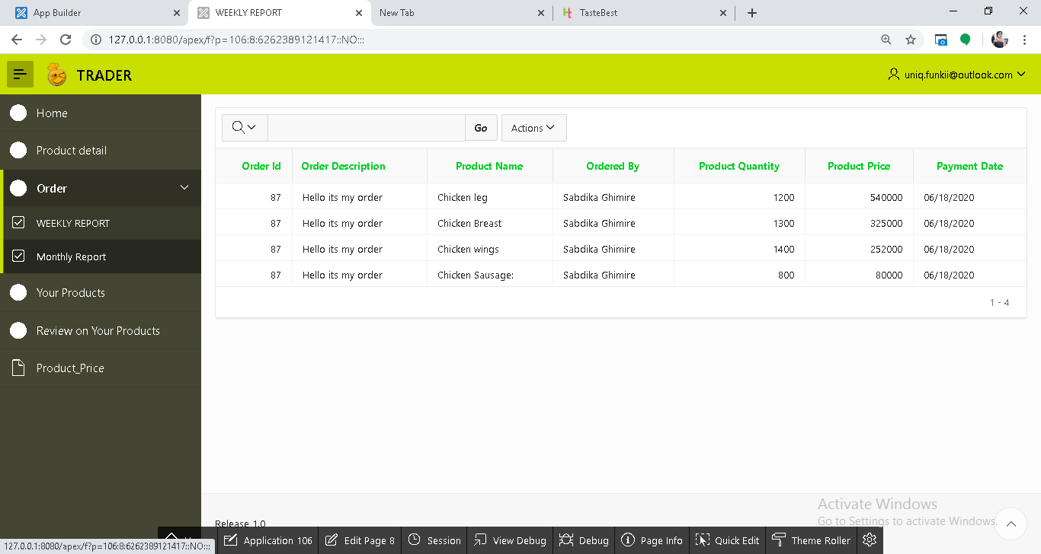

Monthly report

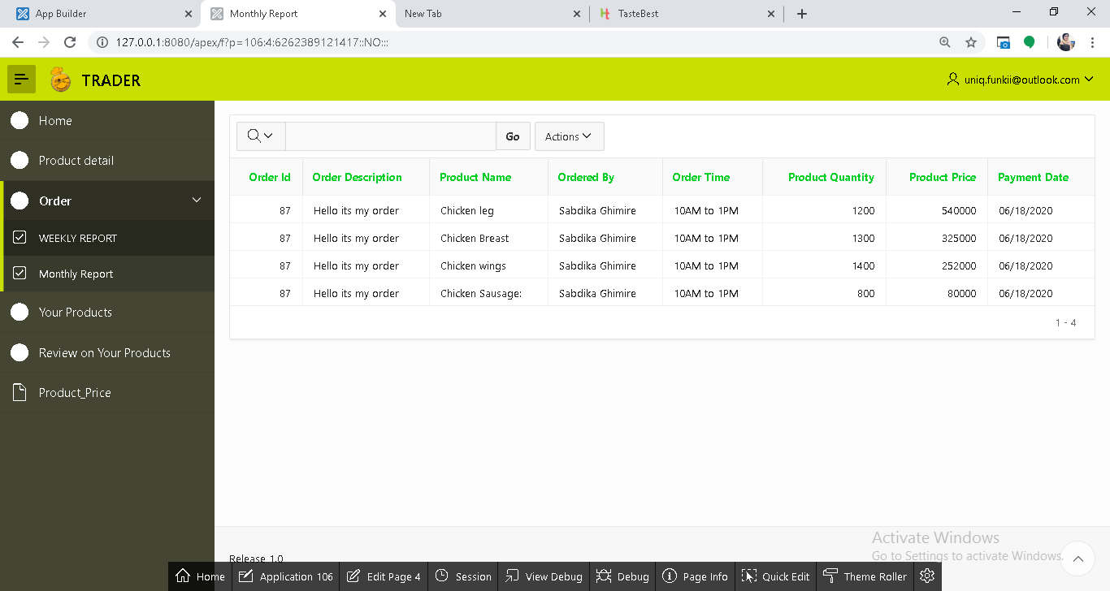

Weekly report

1. Clicking on ‘Your Products’ views the detail information table about product related to the respective trader.

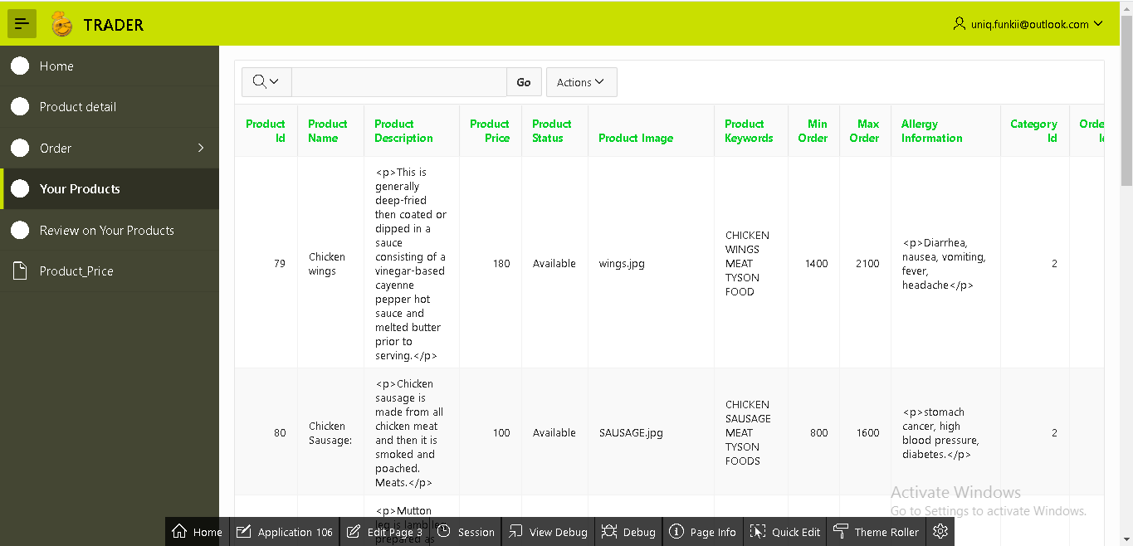

1. Similarly, clicking on ‘Review on your Products’ views the comment passed by customers on the products.

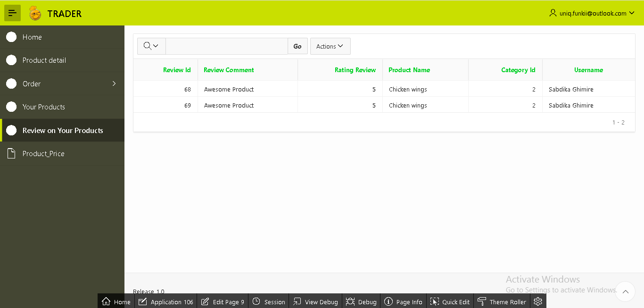

1. As well as, if you select ‘Product_Price’ in this interface it will show the bar diagram about the price of product which helps to remember which product is expensive and which is not.

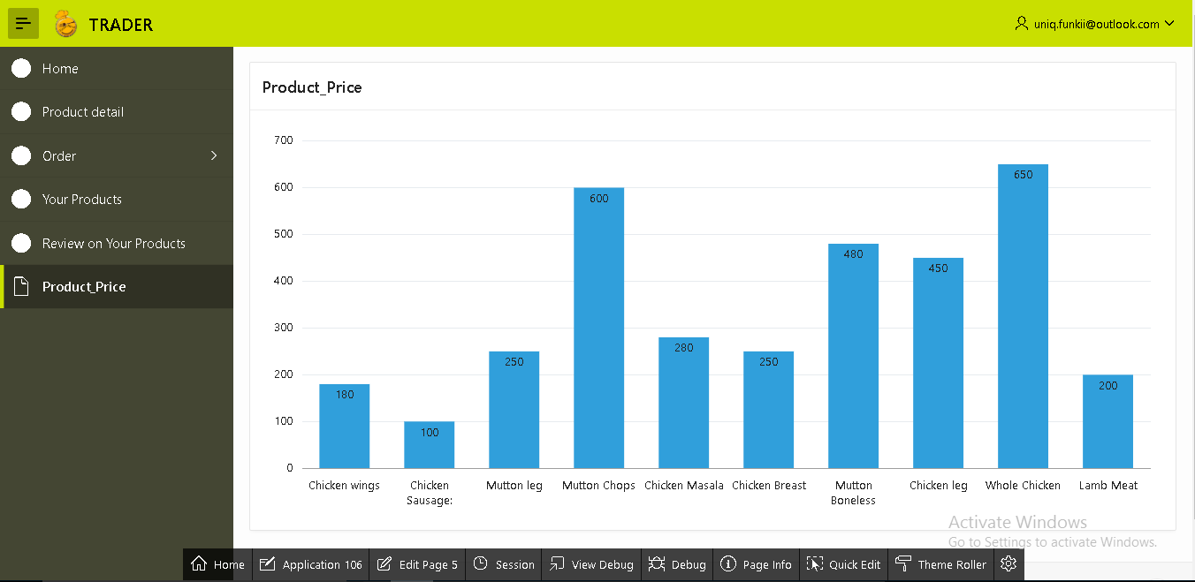

1. Lastly, the sign out option is on the top right side of the page through which trader can sign out their account.

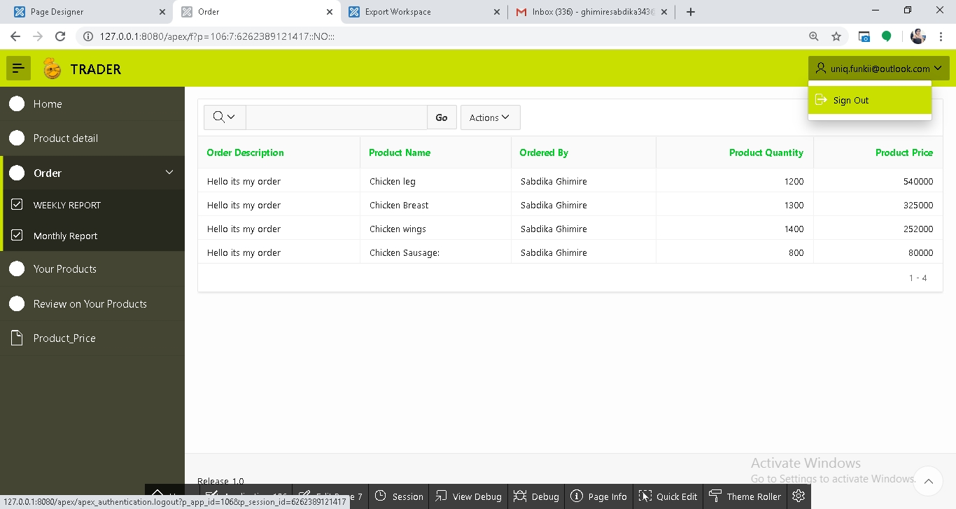

Thank you